|  |
| --- |
| NetEnrich Technologies |
| Updating VM Backup Policy |
| Manual Approach – Through Azure Portal |
|  |
| **SavindraSingh Shahoo** |
| **15-Sep-16** |

|  |
| --- |
| This document contains the manual steps involved in updating VM Backup Policy object through Azure Portal. |

# Updating Backup Policy Manually through Azure Portal

## Step 1: Finding all Recovery Services vaults

On the Azure Portal main screen, Click on ‘More services’ in the menu items and enter the keywords as Recovery Services. Click on ‘Recovery Services vaults from the results listed below.

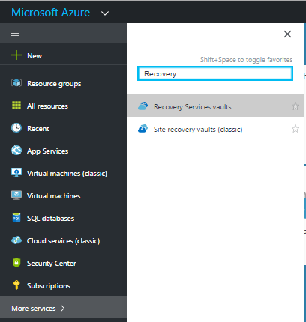

## Step 2: Selecting Recovery Services vault

Click on the correct Recovery Services vault or enter vault name as keyword to search as shown below.

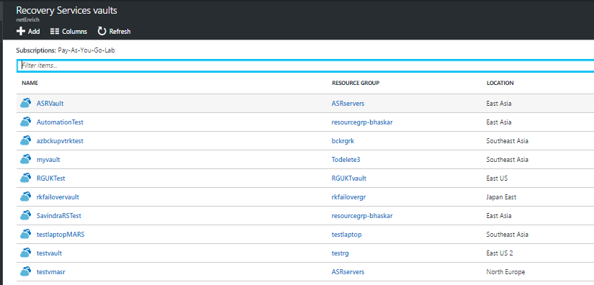

## Step 3: Opening Recovery Services vault settings

A property window will be visible as shown below. Click on All settings link from the same.

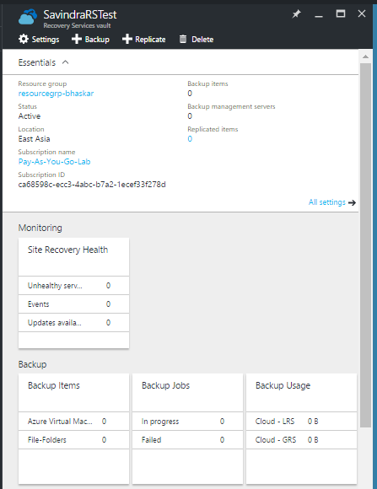

## Step 4: getting List of Backup policy objects

Select Backup Policies from the Settings window.

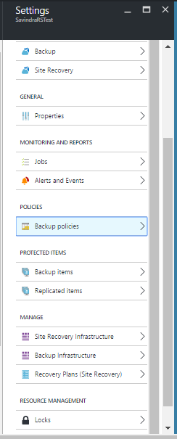

## Step 5: Selecting Backup Policy object

Select Backup policy you want to modify.

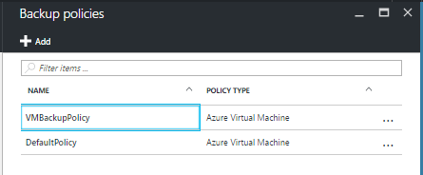

## Step 6: Updating Backup Policy object

Update the Backup policy settings as required.

